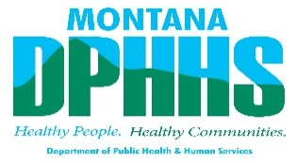
Resources for the Public During the COVID-19 Outbreak
During such a trying time for our nation and state, it is more important than ever that Montanans help each other. Below is a list of organizations and resources that are still available to help citizens during the COVID-19 outbreak and response. Many of these organizations can provide services remotely so you can access the help you need from home.
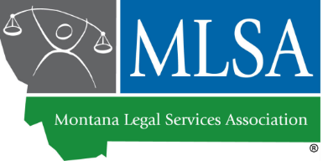
Montana Legal Services Association: Legal issues don't stop just because businesses and schools are closed. Montana Legal Services Association can help individuals with civil legal needs for free during the COVID-19 outbreak. Call 1-800-666-6899 or apply online at https://www.mtlsa.org/apply-for-services/ [mtlsa.org]. For more legal resources, visit www.MontanaLawHelp.org.
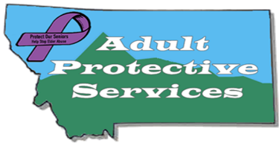
Adult Protective Services: APS is continuing to investigate all allegations of abuse, neglect, and exploitation of vulnerable adults during the COVID-19 pandemic. Because intake staff are operating from the safety of their homes, APS asks that, if at all possible, you submit referrals at www.aps.mt.gov . If you do not have internet capabilities, please call 1 (844) 277-9300.
APS is seeing an increase in scams relating to COVID-19. Public updates can be found on the APS Facebook page: https://www.facebook.com/APSMONTANA/ .
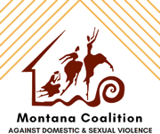
Montana Coalition Against Domestic and Sexual Violence: The Governor’s stay at home order states that individuals experiencing harm can still leave their home if necessary, to protect their safety. For more information about the resources in your community, please visit our website at https://mcadsv.com/about/victim-service-programs-by-region/ [mcadsv.com] or by dialing 1-888-404-7794.
COVID-19 Hotline: Montana public health agencies and the Governor's Coronavirus Task Force are actively working to limit the spread of novel coronavirus in Montana. Call 1-888-333-0461, visit https://covid19.mt.gov/, or email COVID19@mt.gov for more information.

